10. HOUSE PRICE PREDICTION USING MACHINE LEARNING

AIM
To develop a Machine Learning model for House Price Prediction using house features such as area, bedrooms, bathrooms, age, parking, and floors, and predict the price of a new house using regression algorithms.

SOFTWARE REQUIRED
- Python 3.x
- Jupyter Notebook
- Pandas
- NumPy
- Matplotlib
- Scikit-learn
- Windows/Linux Operating System

ALGORITHM
- Create and load the house price dataset.
- Check and preprocess the data.
- Select house features as input and price as the target.
- Split the dataset into training and testing data.
- Train Linear Regression, Decision Tree, and Random Forest models.
- Predict house prices using the trained models.
- Evaluate the models using MSE and R² Score.
- Use the trained Random Forest model to predict the price of a new house.
PROGRAM
import pandas as pd
import matplotlib.pyplot as plt
from sklearn.model_selection import train_test_split
from sklearn.linear_model import LinearRegression
from sklearn.metrics import mean_squared_error, r2_score

data = {
'Area': [800, 1000, 1200, 1500, 1800, 2000, 2200, 2500, 2800, 3000, 3200, 3500, 3800, 4000, 4500],
'Bedrooms': [2, 2, 2, 3, 3, 4, 4, 4, 5, 5, 5, 6, 6, 6, 7],
'Bathrooms': [1, 1, 2, 2, 2, 3, 3, 4, 4, 4, 5, 5, 5, 6, 6],
'Age': [15, 12, 10, 8, 7, 5, 6, 4, 3, 5, 2, 3, 4, 2, 1],
'Price': [20, 25, 30, 38, 45, 52, 58, 65, 73, 78, 85, 95, 105, 115, 130]
}
df = pd.DataFrame(data)

df
OUTPUT
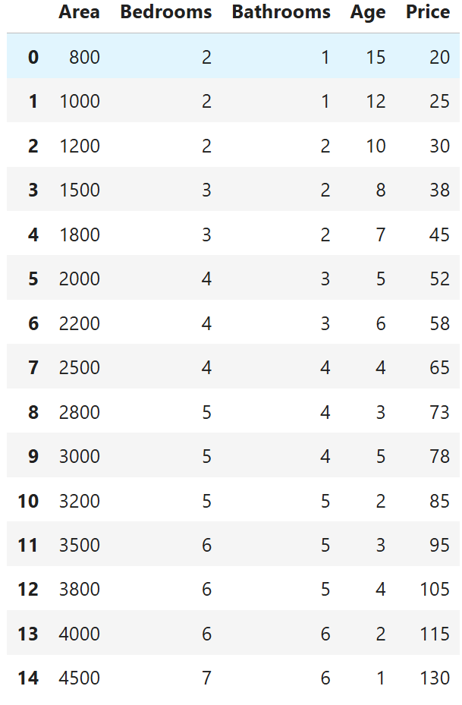
PROGRAM
print("Number of rows and columns:", df.shape)
print("\nMissing values:")
print(df.isnull().sum())
OUTPUT
Number of rows and columns: (15, 5)

Missing values:
Area 0
Bedrooms 0
Bathrooms 0
Age 0
Price 0
dtype: int64

PROGRAM
X = df[['Area', 'Bedrooms', 'Bathrooms', 'Age']]
y = df['Price']
print("Input Features:")
print(X)
print("\nTarget Price:")
print(y)
OUTPUT
Input Features:
Area Bedrooms Bathrooms Age
0 800 2 1 15
1 1000 2 1 12
2 1200 2 2 10
3 1500 3 2 8
4 1800 3 2 7
5 2000 4 3 5
6 2200 4 3 6
7 2500 4 4 4
8 2800 5 4 3
9 3000 5 4 5
10 3200 5 5 2
11 3500 6 5 3
12 3800 6 5 4
13 4000 6 6 2
14 4500 7 6 1

Target Price:
0 20
1 25
2 30
3 38
4 45
5 52
6 58
7 65
8 73
9 78
10 85
11 95
12 105
13 115
14 130
Name: Price, dtype: int64

PROGRAM

X_train, X_test, y_train, y_test = train_test_split(
X, y, test_size=0.2, random_state=42
)
print("Training data:", len(X_train))
print("Testing data:", len(X_test))

OUTPUT
Training data: 12
Testing data: 3

PROGRAM
model = LinearRegression()
model.fit(X_train, y_train)

y_pred = model.predict(X_test)
print("Actual Prices:")
print(list(y_test))
print("\nPredicted Prices:")
print([round(price, 2) for price in y_pred])

OUTPUT
Actual Prices:
[78, 95, 20]

Predicted Prices:
[np.float64(83.12), np.float64(98.0), np.float64(23.22)]

PROGRAM
mse = mean_squared_error(y_test, y_pred)
r2 = r2_score(y_test, y_pred)
print("Mean Squared Error:", round(mse, 2))
print("R2 Score:", round(r2, 2))
OUTPUT
Mean Squared Error: 15.18
R2 Score: 0.99

PROGRAM
new_house = pd.DataFrame({
'Area': [2000],
'Bedrooms': [4],
'Bathrooms': [3],
'Age': [3]
})
predicted_price = model.predict(new_house)
print("New House Details")
print("-----------------")
print("Area: 2000 sq.ft")
print("Bedrooms: 4")
print("Bathrooms: 3")
print("Age: 3 years")
print("\nPredicted House Price:",
round(predicted_price[0], 2), "Lakhs")
OUTPUT
New House Details
-----------------
Area: 2000 sq.ft
Bedrooms: 4
Bathrooms: 3
Age: 3 years
Predicted House Price: 47.96 Lakhs

PROGRAM
plt.scatter(y_test, y_pred)
plt.xlabel("Actual Price (Lakhs)")
plt.ylabel("Predicted Price (Lakhs)")
plt.title("Actual vs Predicted House Prices")
plt.show()
OUTPUT
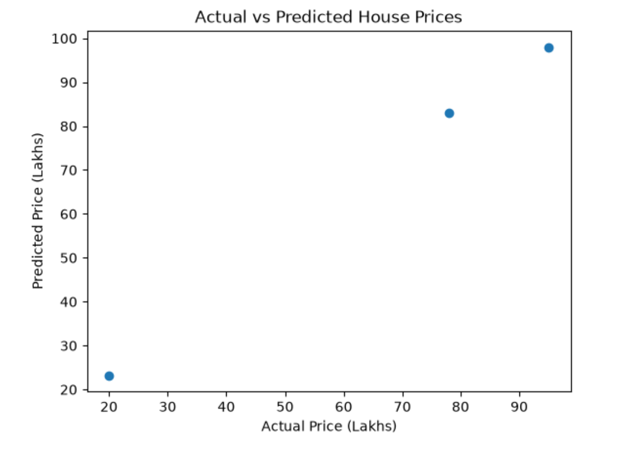
PROGRAM
print("House Price Prediction Model")
print("----------------------------")
print("Area Coefficient:", round(model.coef_[0], 4))
print("Bedrooms Coefficient:", round(model.coef_[1], 4))
print("Bathrooms Coefficient:", round(model.coef_[2], 4))
print("Age Coefficient:", round(model.coef_[3], 4))
print("Intercept:", round(model.intercept_, 4))
OUTPUT
House Price Prediction Model
----------------------------
Area Coefficient: 0.0296
Bedrooms Coefficient: 1.2411
Bathrooms Coefficient: 1.5642
Age Coefficient: 1.3674
Intercept: -25.0368

PROGRAM
print("========== HOUSE PRICE PREDICTION ==========")
print("\nModel: Linear Regression")
print("\nModel Performance")
print("-----------------")
print("Mean Squared Error:", round(mse, 2))
print("R2 Score:", round(r2, 2))
print("\nNew House Prediction")
print("--------------------")
print("Area: 2000 sq.ft")
print("Bedrooms: 4")
print("Bathrooms: 3")
print("Age: 3 years")
print("Predicted Price:", round(predicted_price[0], 2), "Lakhs")
print("\n========== PROJECT COMPLETED ==========")

OUTPUT
========== HOUSE PRICE PREDICTION ==========

Model: Linear Regression

Model Performance
-----------------
Mean Squared Error: 15.18
R2 Score: 0.99

New House Prediction
--------------------
Area: 2000 sq.ft
Bedrooms: 4
Bathrooms: 3
Age: 3 years
Predicted Price: 47.96 Lakhs

========== PROJECT COMPLETED ==========

PROGRAM
# Final verification
print("========== FINAL RESULT ==========")
print("Model: Linear Regression")
print("Mean Squared Error:", round(mse, 2))
print("R2 Score:", round(r2, 2))
print("\nNew House:")
print("Area: 2000 sq.ft")
print("Bedrooms: 4")
print("Bathrooms: 3")
print("Age: 3 years")
print("Predicted Price:", round(predicted_price[0], 2), "Lakhs")
print("\nProject completed successfully!")
OUTPUT
========== FINAL RESULT ==========
Model: Linear Regression
Mean Squared Error: 15.18
R2 Score: 0.99

New House:
Area: 2000 sq.ft
Bedrooms: 4
Bathrooms: 3
Age: 3 years
Predicted Price: 47.96 Lakhs

Project completed successfully!

